**Laboratory 3:**

Magnetism

**Name:** Omar Ozgur

**Date:** Feb 4, 2016

**Lab:** Section 7, Thursday 8:00am

**TA:** Nicholas Rombes

**Lab Partner:** Uday Alla, Cyril Nader

**1. Introduction**

The objective of this laboratory experiment was to examine various properties of magnetic fields. In the first section of the lab, a Hall probe connected to a Gaussmeter was attached to a linear track, and was used to measure the strength of a generated magnetic field at various points around a toroid. In the second experiment, the same track was used to move the probe away from a fixed permanent magnet along the *z* axis (0°), and along the *ρ* axis (90°). Data was recorded in small increments, and was used to help determine the magnetic field’s spatial dependence along multiple axes. In the next section, the track was placed vertically, and a permanent magnet was attached to it so that the flat surface could be raised or lowered. A gram scale was placed next to the track, and a second magnet was placed on the scale so that it lay directly under the first magnet. The force between the magnets was recorded at small increments of distance, and the trend in the data was analyzed. In another section, various materials were moved near a magnet, and the reflection of a laser from an attached mirror was used to determine if the materials were paramagnetic or diamagnetic. In the last section of the experiment, a current was applied to a coil, and the induced voltage of an outer coil of wire was analyzed. The analysis of the data from these experiments helped to verify many theoretical properties of magnetic fields.

**2. Experimental Results**

2.1 Magnetic Fields Produced by Line Currents

In the first section of the experiment, a DC power supply was used to provide 15 ± 1 V to a large pre-constructed toroid, which is displayed in figure 1.

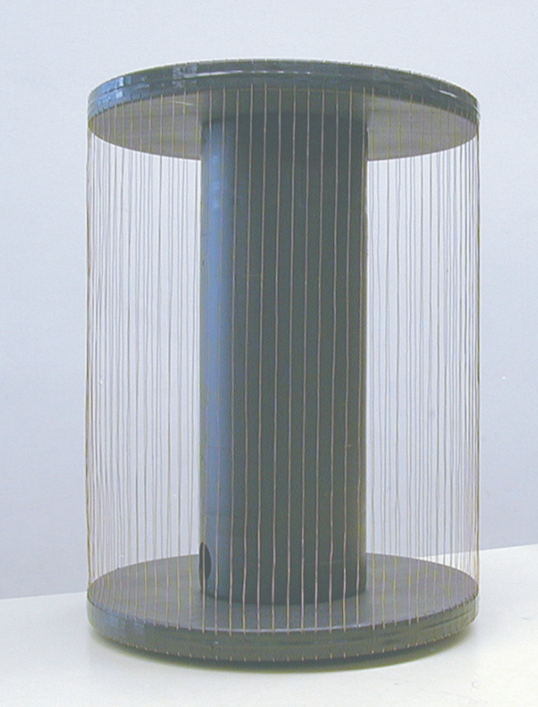

Figure : Toroid Setup: This image displays the toroid that was used in this experiment. Voltage from a DC power supply was driven through the wires, which theoretically generated a magnetic field in accordance with Ampere’s Law. (Source: UCLA Physics 4BL Lab Manual, Winter 2016)

In order to measure the strength of the magnetic field at various points around the toroid, a Gaussmeter was used to display measurements from a Hall probe. By rotating the probe between the conductors of the toroid, it was determined that the measurements were the largest when the magnetic field was directed against the flat side of the filament. By inserting the probe at many positions with the same radius *ρ*, it was observed that the magnetic field strength was roughly the same all around the toroid. This helps to verify that the magnetic field only varies based on the enclosed current, which proves the results of Ampere’s Law

$\oint{B∙dl=2πρB_{φ}=μ_{0}I_{enclosed}=μ_{0}NI}$ (1)

The next step of this experiment involved measuring the radial dependence of the magnetic field. The radius value at the edge of the inner conductor was denoted as *a*, and the radius value at the outer edge of both conductors was denoted as *b*. In this case, *a* was given as 3.2 cm with negligible uncertainty, and *b* was found to be 15.50 ± 0.05 cm. While moving the Hall probe along a linear track away from the center of the toroid, the strength of the magnetic field was recorded at linear increments of 0.50 ± 0.05 cm. The recorded data is shown in figure 2, and is split into the cases of radius *r* < a, a < r < b, and r > b.

Figure : Magnetic Field Strength for a Toroid: The data shown in this graph visually displays the magnetic field trends associated with a typical toroid. The blue data points represent the field strength inside the inner conductor, the red points represent the strength between the two conductors, and the green points represent the strength outside of the outer conductor. The trends generally follow the expectations of Ampere’s Law, but deviations are present because the Hall probe could not perfectly measure values at the precise locations desired.

The voltage that was applied to the current was measured to be 15 ± 1 V. By removing the power cables, and plugging them into a multimeter, the resistance was found to be 10.6 Ω. By dividing the voltage by the resistance, the current throughout the toroid could be determined.

2.2 Magnetic Fields Produced by Permanent Magnets

In the second part of the experiment, a linear track was used to move the Hall probe along the *z* axis (0°), and the *ρ* axis (90°), of a cylindrical permanent magnet, as shown in figure 3.

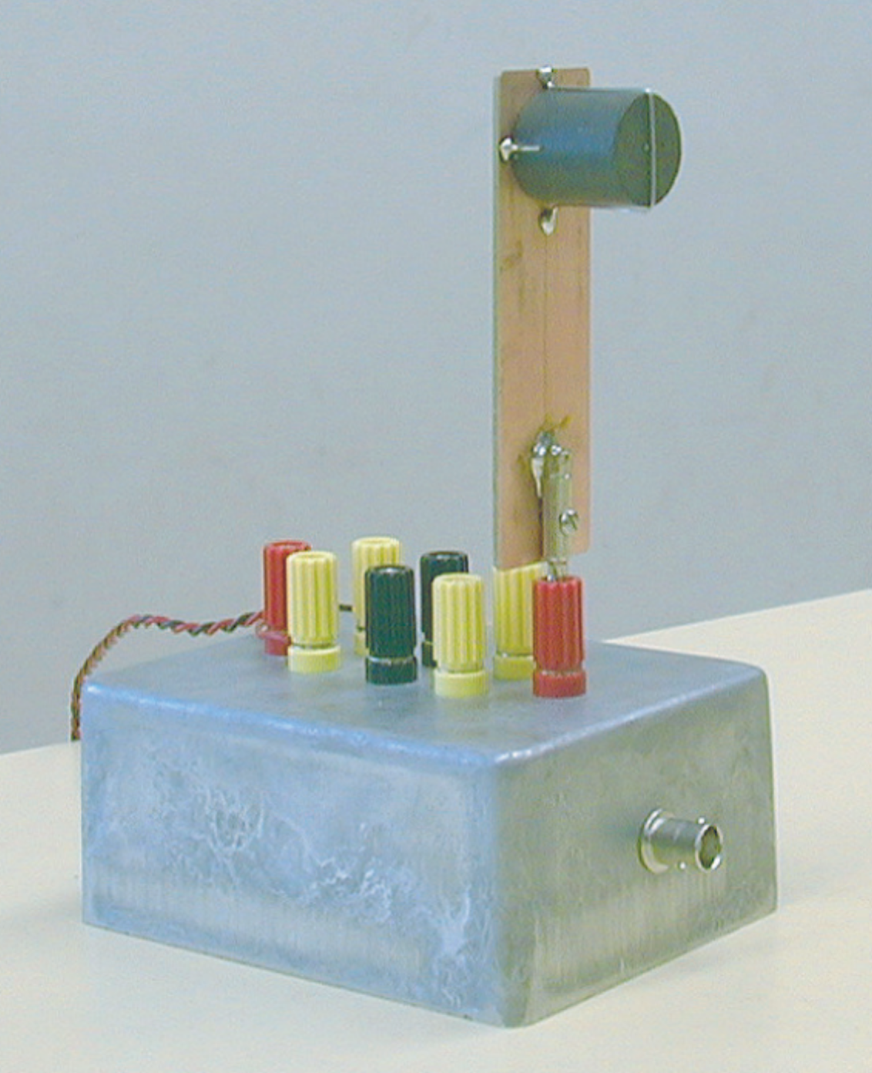

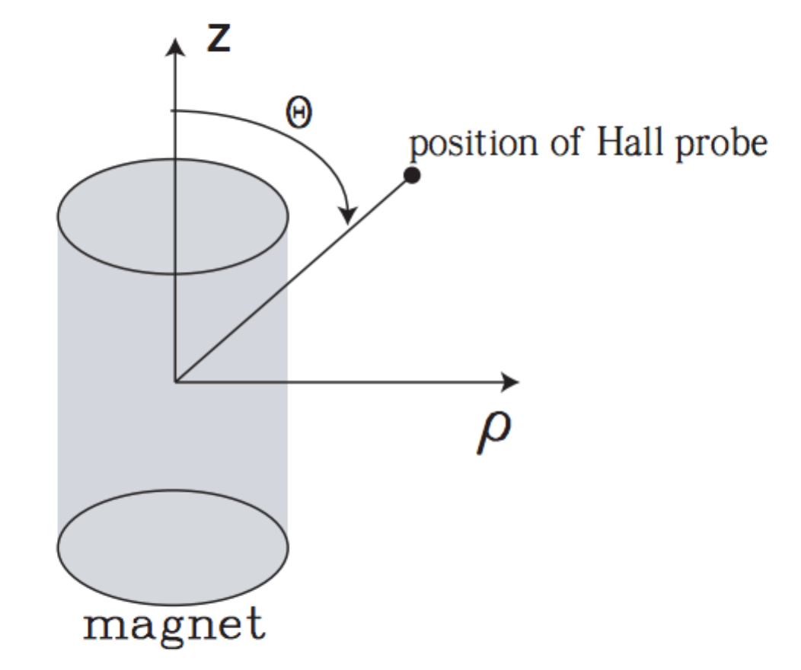

Figure : Experiment 2 Setup: The left image displays the locations of the *z* and *ρ* axes along the permanent magnet. The right image displays the setup of the magnet that allowed the Hall probe to be easily moved along the *z* axis. By moving the Hall probe along a specific axis, and recording data shown on the Gaussmeter, various properties of the magnetic field could be determined. (Source: UCLA Physics 4BL Lab Manual, Winter 2016).

After moving the Hall probe away from the permanent magnet at increments of 0.50 ± 0.05 cm, starting at 2.00 ± 0.05 cm, the recorded magnetic strength values could be plotted. The values recorded along the *z* axis are shown in figure 4, and the values recorded along the *ρ* axis are shown in figure 5. The results could be compared to expected theoretical results by linearizing the data and performing regression analysis.

Figure : Magnetic Field Strength Along *z* Axis: This graph displays the recorded magnetic field strength values along the *z* axis of the permanent magnet. The initial offset was 2.00 ± 0.05 cm. The data shows that the magnetic field is strongest at points close to the magnet. Since the Hall probe filament was facing the *z* axis, the data shows that the vector direction of the field was directed away from the closest pole of the magnet. By linearizing the data, the functional form can be determined.

Figure : Magnetic Field Strength Along *ρ* Axis: This graph displays the recorded magnetic field strength values along the *ρ* axis of the permanent magnet. The initial offset was 2.00 ± 0.05 cm. The data shows that the magnetic field is strongest at points close to the magnet. These values were gathered with the Hall probe filament facing perpendicular to the axis, which helps to show that the vector direction of the field was directed around the magnet, from one pole to the other. The functional form of the data points could be determined through analysis of linearized data.

2.3 Force Between Magnets

In the third section of the experiment, a linear track was placed vertically, and a permanent magnet was attached so that one face of the magnet was directed downward. Next, a gram scale was placed next to the track, and a second permanent magnet was placed on top of the scale. While moving the first magnet on the track up or down so that the two magnets repelled each other at various distances, the mass reading on the scale varied accordingly. The experiment setup is shown in figure 6.

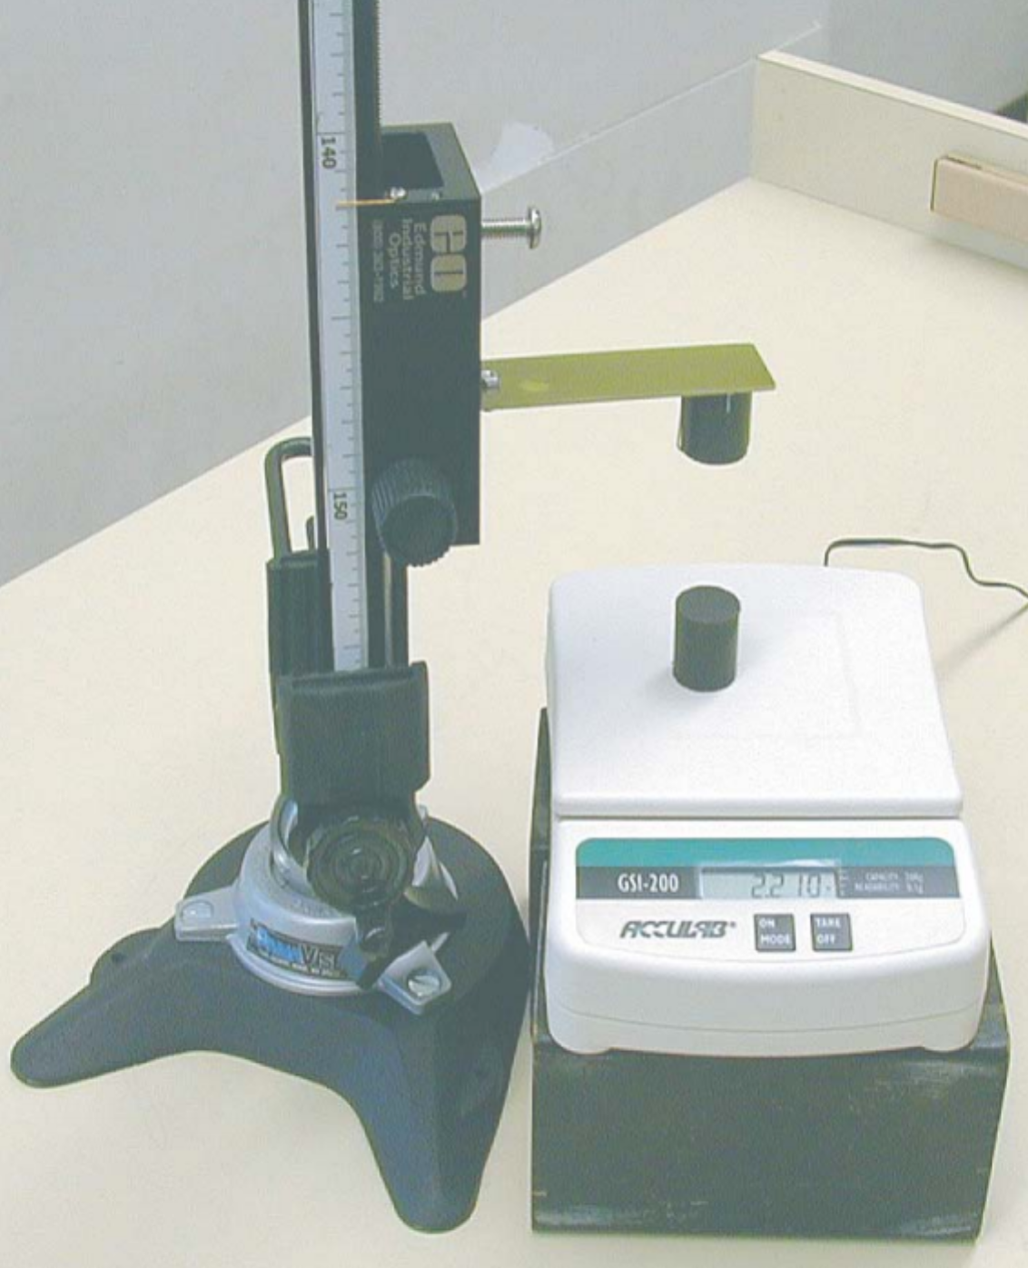

Figure : Force Between Magnets Setup: This image shows the setup for the experiment that involved analyzing the force between two repelled magnets. The readings on the gram scale got larger as the magnets were moved closer to each other, and got smaller as the magnets were moved further apart. These mass readings were converted to force, and the data was plotted in figure 7 for further analysis. (Source: UCLA Physics 4BL Lab Manual, Winter 2016)

After recording data at increments of 0.50 ± 0.05 cm, the recorded mass values could be used to calculate the force between the two magnets at the specific distances that were used. The data that was gathered is displayed in figure 7. The results could be further analyzed by linearizing the data and comparing the information to theoretical trends.

Figure : Force Between Magnets: The data points shown in this graph represent the measured repulsion force between two magnets at various distances. The initial offset was 1.00 ± 0.05 cm. As the magnets were moved further apart, the force between them became smaller. By linearizing the data,, and performing regression analysis, the functional form could be compared with theoretical results.

2.4 Paramagnetism and Diamagnetism

In the next part of the laboratory experiment, the goal was to determine if various materials were diamagnetic or paramagnetic. In order to do so, a small magnet and mirror were hung from a horizontal rod with a thin piece of string. In order to prevent constant movement, a piece of copper was placed behind the magnet, which helped to damp oscillations. Afterwards, a laser pointer was used to reflect light from the mirror, onto a large piece of paper that was held up by a metal stand. This was done so that any small rotation of the mirror would be magnified on the piece of paper. The described setup is shown in figure 8.

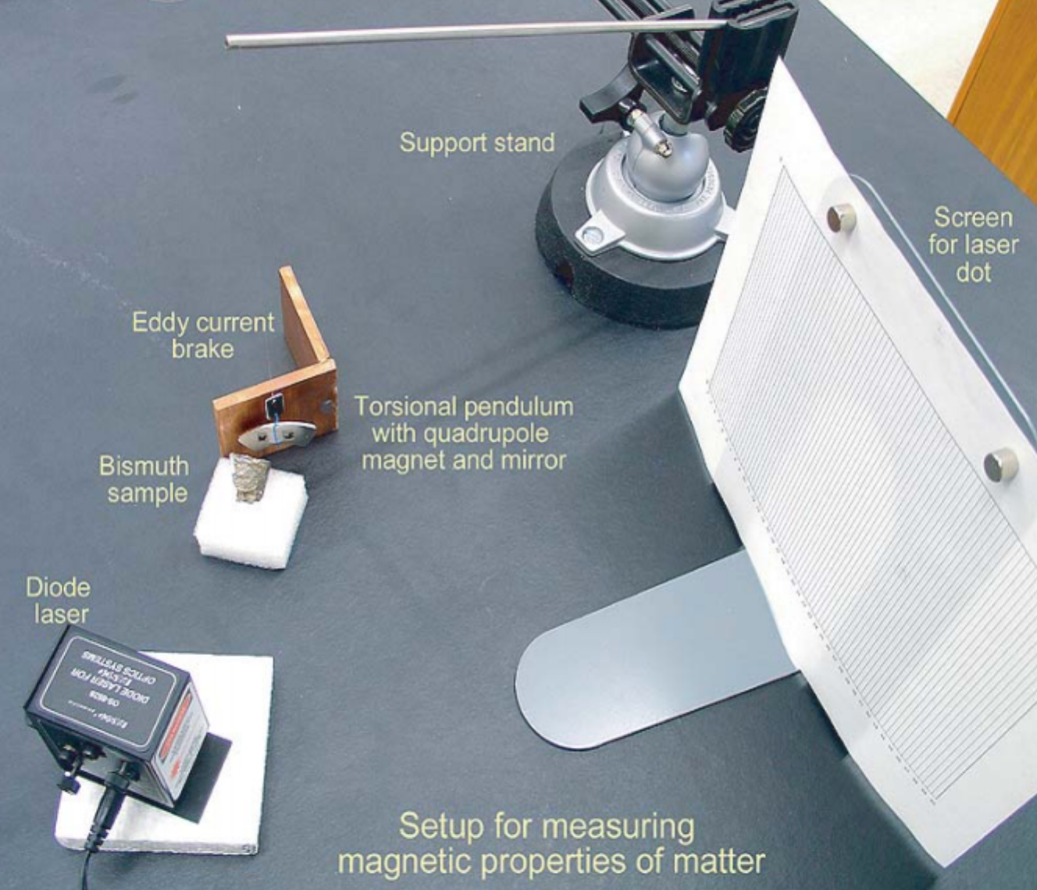

Figure : Paramagnetism and Diamagnetism Setup: This image shows the setup of the experiment that was used to test for paramagnetism and diamagnetism. A small magnet and mirror were hung from a horizontal rod, and the light from a laser was reflected off of the mirror, onto a large piece of paper. When various materials were moved towards the magnet, the rotation of the mirror could be used to determine if the material was diamagnetic of paramagnetic. (Source: UCLA Physics 4BL Lab Manual, Winter 2016)

After moving various materials towards one side of the magnet, the observed rotation of the mirror based on the reflection of the laser was used to determine if the materials were paramagnetic or diamagnetic. The materials that repelled the magnet were recorded as diamagnetic, and those that attracted the magnet were recorded as paramagnetic. The results are shown in table 1.

|  |  |  |  |  |  |  |  |  |
| --- | --- | --- | --- | --- | --- | --- | --- | --- |
| Material | Cu | Al | Ta | Bi | C | Fe | Ni | Glass |
| Paramagnetic (P) or Diamagnetic (D) | D | D | D | D | D | P | P | D |
| Strength (Scale 0-10) | 4 | 2 | 2 | 3 | 5 | 9 | 7 | 1 |

Table : Paramagnetism and Diamagnetism Results: This table shows which materials were found to be diamagnetic, and which were found to be paramagnetic. Some of the materials showed clear results, but others were very difficult to determine based on the rotation of the mirror. For this reason, the strength of the reactions were also noted in this table on a scale from 1 to 10.

2.5 Faraday’s Law

In the last part of the experiment, a solenoid was placed inside a Faraday coil, and was connected in series with a 10.60 ± 0.05 Ω resistor. A function generator was used to apply voltage in the form of a 1 kHz sine wave to the circuit. By using channel 0 of an analog to digital converter (ADC) to measure the voltage across the resistor, Ohm’s law could be used to determine the current. The induced voltage in the Faraday coil was recorded through channel 1 of the ADC with the help of a myDAQ system. After using the provided “4BL” software to record 1000 data points at a rate of 100,000 points/sec, the data was used to created the graphs shown in figures 9 and 10. The analysis of the data could be used to verify the results of equations based on Faraday’s law.

Figure : Inner Coil Current: The data points in this graph show the current in the solenoid over time. The current was calculated by dividing the recorded voltage readings by the resistance of the resistor that was used. The peaks of the sinusoidal pattern indicate the times where the current in the solenoid was largest. This data could be compared with the data in figure 10 to see if the induced voltage followed expected results based on Faraday’s law.

Figure : Outer Coil Induced Voltage: The data points in this graph show the induced voltage in the Faraday coil over time. The peaks of the sinusoidal pattern show the times when the induced voltage was largest. By comparing this data with the graph in figure 9, it can be seen that the largest induced voltages occurred when the current through the inner solenoid was approximately 0 A. This information can be used to verify theoretical results based on Faraday’s law.

**3. Analysis**

3.1 Magnetic Fields Produced by Currents

Based on equation 2, it was expected that the magnetic field strength measurements between the two conductors of the toroid should be proportional to $\frac{1}{r}$, where *r* corresponds to the distance of the Hall probe from the center of the toroid.

$B_{Φ}=\frac{μ_{0}I}{2πr}$ (2)

In order to see if the collected data followed the expected trend, the magnetic field strength was plotted against $\frac{1}{r}$, as shown in figure 11.

Figure : Magnetic Field Strength Against 1/r: This graph shows the magnetic field strength values plotted against $\frac{1}{r}$, where *r* represents the distance of the Hall probe from the center of the toroid. Most of the data points lie extremely close to the linear trend line that is displayed, showing a strong correspondence with the expected trend. By performing linear regression analysis, the correlation coefficient was found to be approximately 0.9957, which helps to verify the results of equation 2.

By using Microsoft Excel to perform regression analysis on the data shown in figure 11, the square of the correlation coefficient was found to be approximately 0.9917. Based on this information, the correlation coefficient was found to be 0.9959, which is very close to the theoretical coefficient of 1. This verifies that the magnetic field strength in a toroid does vary in proportion to $\frac{1}{r}$.

3.2 Magnetic Fields Produced by Permanent Magnets

In order to compare the measured magnetic field data to the theoretical results for a permanent magnet, equations 3 and 4 were utilized.

$B_{z}=\frac{μ_{0}}{4π}\frac{m}{r^{3}}(3\cos^{2}{θ}-1)$ (3)

$B_{ρ}=\frac{μ_{0}}{4π}\frac{3m}{2r^{3}}sin2θ$ (4)

These equations show that the magnetic field strength should vary in proportion with $\frac{1}{r^{3}}$, where *r* represents the distance of the Hall probe from the permanent magnet along a specified direction. In order to test this, the recorded magnetic field strength values along the *ρ* axis were plotted against $\frac{1}{r^{3}}$. The graph is shown in figure 12.

Figure : Magnetic Field Strength Against 1/r3: This graph shows the recorded magnetic field strength values plotted against $\frac{1}{r^{3}}$ along the *ρ* axis of the magnet. Most of the data points lie very close to the linear trend line that is displayed, indicating strong correspondence with the theoretical trend. After performing regression analysis on the data, the correlation coefficient was found to be approximately 0.9957, which helps to verify the results of equations 3 and 4.

By using Microsoft Excel to perform regression analysis on the data shown in figure 12, the square of the correlation coefficient was found to be approximately 0.9914. Based on this value, the correlation coefficient was approximately 0.9957, which is close to the ideal value of 1. This helps to verify that the magnetic field strength from a permanent magnet is proportional to $\frac{1}{r^{3}}$.

3.3 Force Between Magnets

After recording the measured repulsion force between two magnets at various distances, as shown in figure 7, the goal was to see if the force values corresponded to the measured distances with the theoretical proportion $\frac{1}{r^{4}}$, where *r* represents the distance between the magnets. In order to test this, the values for force were plotted against $\frac{1}{r^{4}}$, as shown in figure 13. The force values that are shown were calculated by multiplying the recorded mass values by the gravitational constant of approximately 9.81 m/s2.

Figure : Force Between Magnets Against 1/r4: This graph shows the measured force values between the magnets plotted against $\frac{1}{r^{4}}$. The data points are all very close to the linear trend line that is displayed, shown a strong correlation with the theoretical functional form. By performing regression analysis on the data, the correlation coefficient was found to be approximately 0.9922, which is close to 1. This helps to verify that the force follows the theoretical proportion $\frac{1}{r^{4}}$.

By using Microsoft Excel to perform regression analysis on the data shown in figure 13, the square of the correlation coefficient was found to be approximately 0.9922. Therefore, the correlation coefficient was found to be about 0.9961, which is very close to the ideal value of 1. This verifies that the magnetic force between two permanent magnets is proportional to $\frac{1}{r^{4}}$.

3.4 Paramagnetism and Diamagnetism

As shown in the data in table 1, many of the elements such as copper, carbon, and bismuth were found to be diamagnetic, while others such as iron and nickel were determined to be paramagnetic. Theoretically, the elements that have unpaired electrons are paramagnetic, and those that have all electrons paired are diamagnetic. This was accurately shown based on the experimental results, except for the cases of aluminum and tantalum, which were found to be slightly diamagnetic. The deviation from the expected trend was likely due to the fact that weak responses from the magnet for some materials were difficult to analyze. Although most of the results agreed with the theoretical trends, those that didn’t may have been corrected by using more precise tools to determine the exact rotation of the magnet.

3.5 Faraday’s Law

Based on the data shown in figures 9 and 10, the next goal was to see if the measured induced voltage amplitude *V0* corresponded with the theoretical value based on equation 5, which reduces to equation 6 when the induced voltage *Vind* is at its peak. The variable values and meanings based on equation 6 are shown in table 2.

$V_{ind}=I_{0}μ_{0}ωAnNcos(ωt)$ (5)

$V_{0}=I_{0}μ_{0}ωAnN$ (6)

$A=πr^{2}$ (7)

$σ_{F}=\sqrt{{\left(\frac{∂f}{∂x}\right)}^{2}{\left(σ_{x}\right)}^{2}+{\left(\frac{∂f}{∂y}\right)}^{2}{\left(σ_{y}\right)}^{2}}$ (8)

|  |  |  |  |  |  |  |
| --- | --- | --- | --- | --- | --- | --- |
| Symbol | I0 | μ0 | ω | A | n | N |
| Meaning | Current amplitude in inner coil | Permeability of free space (constant) | Driving frequency of current | Cross sectional area of inner coil | Turns per length for inner coil | Number of turns for outer coil |
| Value | 0.1144 ± 0.0005 A | 4π $∙{10}^{-7}$ $\frac{Wb}{A∙m}$ | 1000 Hz | 0.00038 m2 | 8000 | 100 turns |

Table : Variables Used to Calculate Induced Voltage: This table shows a description of the variables that were used in equation 6 to calculate the induced voltage amplitude *v0*, as well as the values of those variables. The variables *μ0, ω, n,* and *N* were given. The value *A* was found by using known radius 0.011 m in equation 7. The value *I0* was found based on the amplitude of the current shown in figure 9.

By using the information in table 2 to calculate *V0*, the theoretical amplitude of the induced voltage was calculated to be 0.2747 ± 0.0002 V. The uncertainty in the calculation was found through the use of equation 8. Based on the amplitude of the induced voltage seen in figure 10, the experimental value of *V0* was found to be 0.1140620 ± 0.0000005 V. It is clear that this value does not agree with the theoretical value based on the given uncertainty bounds. The percentage of error is approximately 140%. The large amount of error could be due to many factors involved in the creation of the circuit, such as added internal resistance from various components, or an imprecise reading of the frequency that was used.

**4. Conclusion**

Based on the results of the experiment, most of the tested theories involving magnetism were verified. In the sections that involved using the Hall probe to determine the spatial dependence of magnetic fields, the calculated correlation coefficients of measured data based on theoretical functional forms were found to have less than 1% error. Similar results were examined when comparing the measured forces between two magnets to theoretical trends. A similar percentage of error was also calculated when analyzing the repulsion force between permanent magnets at various distances.

In the section of the experiment that involved determining if materials were paramagnetic or diamagnetic, the results mostly correlated with trends involving pairs of electrons in an element’s electron configuration. However, there were 2 elements that deviated from the trend, which was likely due to the difficulty of analyzing the rotation of the magnet in these cases.

In the last part of the experiment, the percentage of error between the theoretical amplitude of the induced voltage in the Faraday coil and the calculated experimental amplitude was approximately 140%. This large percentage of error may have been due to factors such as added internal resistance in the circuit, or an inaccurate frequency reading.

For most sections of the experiment, the experimental results agreed closely with theoretical results. Although there was some discrepancy in measurements based on the Faraday coil, the results can be used to verify many of the classical equations and trends regarding magnetism.